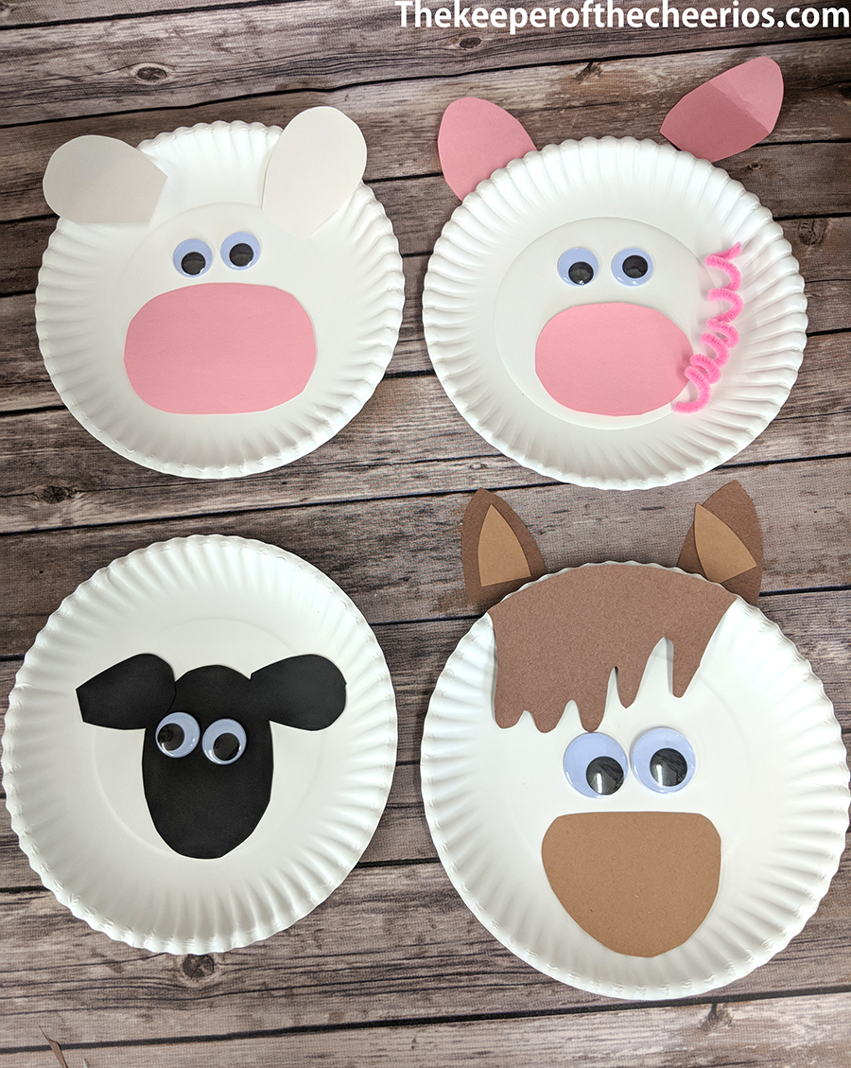
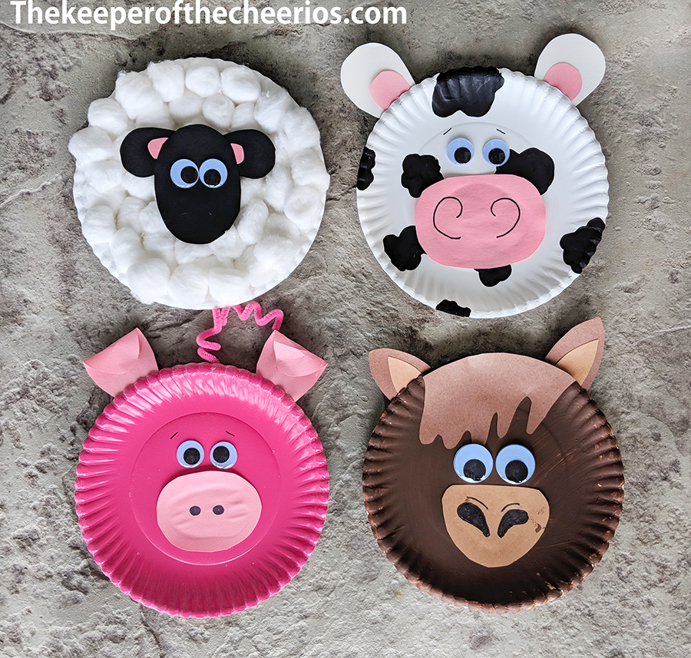

Materials:
- Paper plates
- Craft Paint and brushes
- Craft glue
- Chenille stems (pink)
- Scissors
- Wiggle eyes
- Marker (black)
- Pom poms or cotton balls (white)
Directions:
- Paint your farm animal plates (Pink for pig, Brown for horse, and Black spots for your cow)
- Cut out of black craft paper ears and head for your sheep
- Glue on pom poms or cotton balls all over your plain white plate – cover completely
- Glue on your black ears to your sheep head and glue to the center of your pom pom/ cotton ball covered plate
- Add some wiggle eyes
- For your pig, cut out of craft paper some ears and a nose
- Glue on your ears to the top of your plate on the back side
- Glue on your nose, use your marker to add nose details
- Glue on your wiggle eyes
- Use a pen or marker to wrap your chenille stem around and then glue it to the back of your plate
- For your cow cut out of craft paper some ears and nose- glue on
- Use a black marker to draw on your nose details
- Glue on some wiggle eyes
- For your horse, cut out of craft paper some ears, nose and hair- glue on accordingly
- Glue on some wiggle eyes and use your marker to draw on nose details

