Sheep: Fill-in-the-Blank Activity
This activity will help you assess your knowledge of the

Guidelines
For this activity, print or copy this page on a blank piece of paper. Use the words presented in the word bank to complete the sentence. Neatly write them on the appropriate blank space provided.

Sentences
- Sheep are known to be herbivores or animals with the ability to consume and survive on __________ matter.
- A __________ refers to a young sheep, especially one that is less than one year old or without permanent teeth.
- Sheep __________ is a staple commodity that is used predominantly in cultured dairy products, such as __________ and yogurt.
- Sheep have adapted to living in __________ climates owing to their thick wool coats.
- __________ is used mostly for contact communication, especially between a female sheep and its calf.
- __________ refer to open fields on which livestock are kept for feeding.
- A male sheep, or a __________, is characterized by its large, curled horns.
- __________ was dubbed as the world's most famous __________ for being the first mammal to be cloned.
- __________ is mainly used in making winter clothes because it is warm and __________ enough to resist cold.
- Most breeds of sheep would often produce __________ offspring.

Word Bank
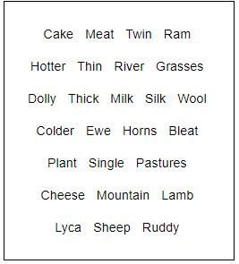

Answer Key
- Plant
- Lamb
- Milk, Cheese
- Colder
- Bleat
- Pastures
- Ram
- Dolly, Sheep
- Wool, Thick
- Twin

