MILK THE COW:

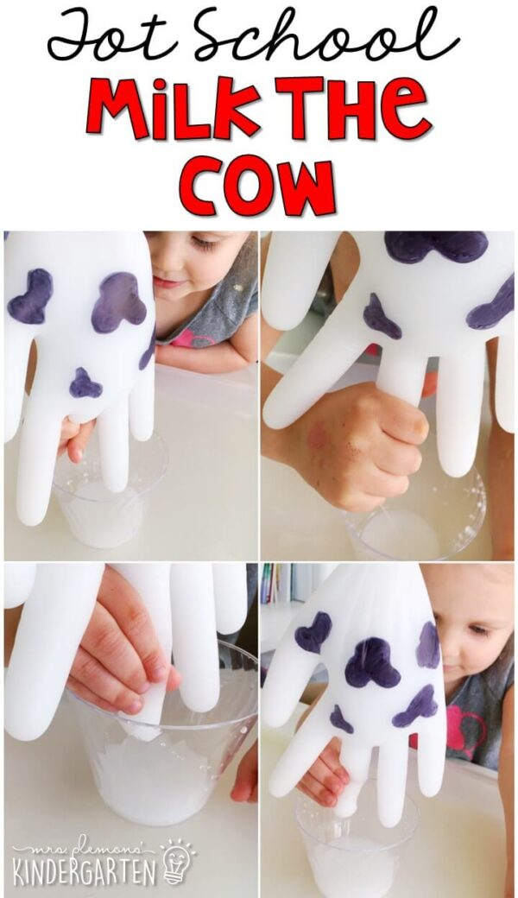
Set up your own little cow milking activity to try out. Mix a tiny bit of white paint with water and pour it into a clear latex glove and closed it off with a rubber band. Draw on a few spots to make it more cow-like, then with it positioned over a cup, poke a tiny hole in the “udders” with the smallest needle you could find. Let the students “milk the cow” by gently squeezing the “udder” (one of the fingers on the latex glove that you poked the hole in) and see how much more “milk” comes out of the cow when the udder is squeezed!

